1. Installing GIT on Linux

sudo dnf install git-all

1. Setting up Git Config before start

git config --global user.name "abhijit2386"

git config --global user.email [abhijit.kumbhar23@gmail.com](mailto:abhijit.kumbhar23@gmail.com)

git config --list

1. Creating a GIT repository

In Windows User

* Create a folder demo_repo

Create file1 & fil2.txt

Git status

Git add file1

Git status

Git add –all (git add .)

Git commit file1 -m “file 1 commit from Windows user”

Git log

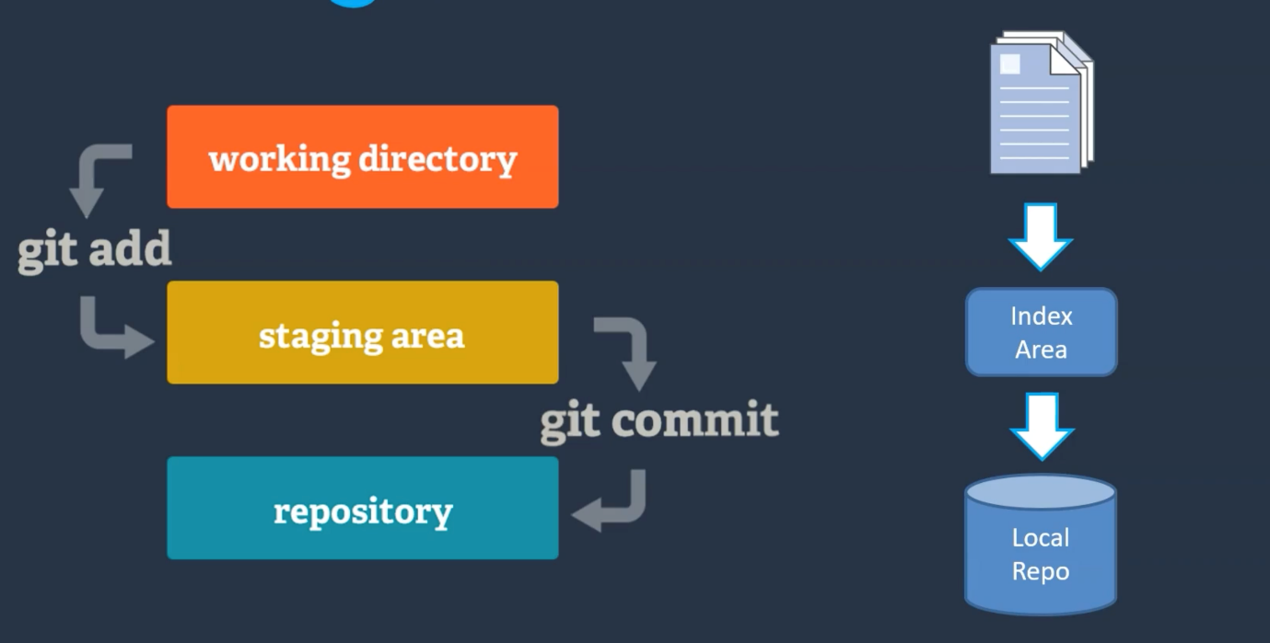

Create a linux machine on AWS and clone the repository

Change the file and commit.

Push the changes using Personal Access Token to Github repository

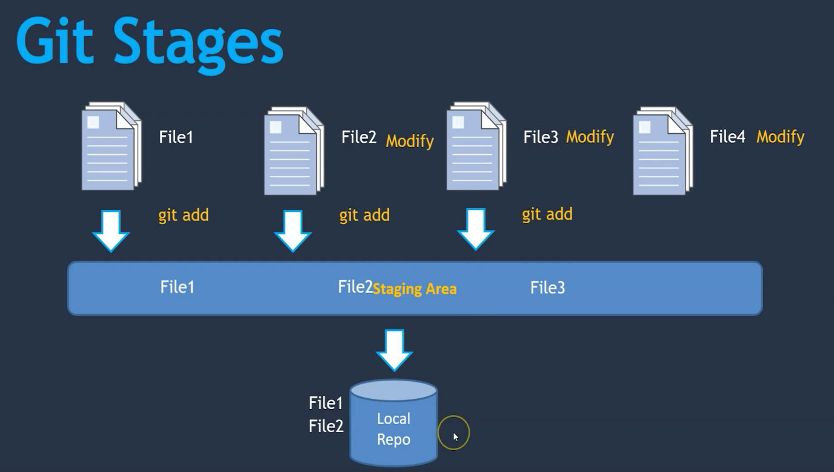

touch file3 file4

ls -lart

git status

git commit -m "file2 commit by Windows" file2.txt

git status

git add file3

git status

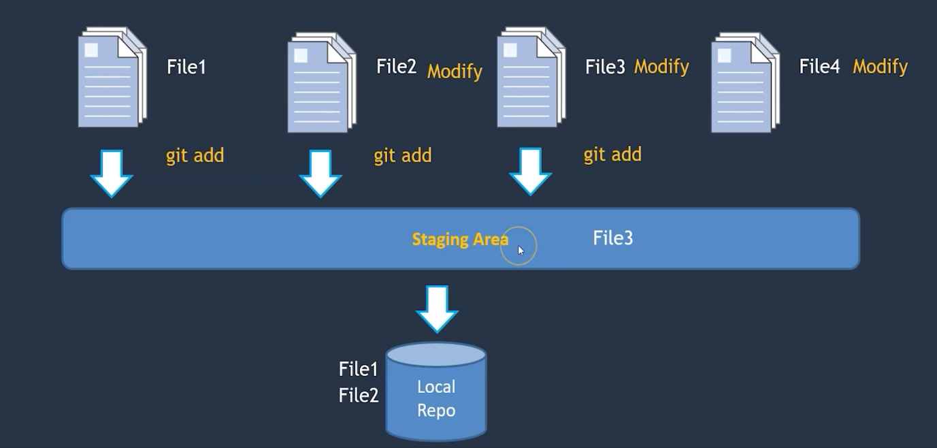

vi file3

vi file4

ls -lrt

vi file2.txt

git status

git add .

git status

git commit -m "adding file3 file4 as well"

git log

ls

vi file1

git status

mv file2.txt file2

git status

git add --all

git status

vi file1

vi file2

git status

git diff // Difference between working directory with staging area

git --staged diff

git diff –staged // Difference between staging and local repository

git status

git diff --staged HEAD // alternative to above cmd

git diff HEAD // Difference between working dir with local repository

* Compare changes done with the commits

git diff 4c939b 1accca

* Creating a GIT HUB account

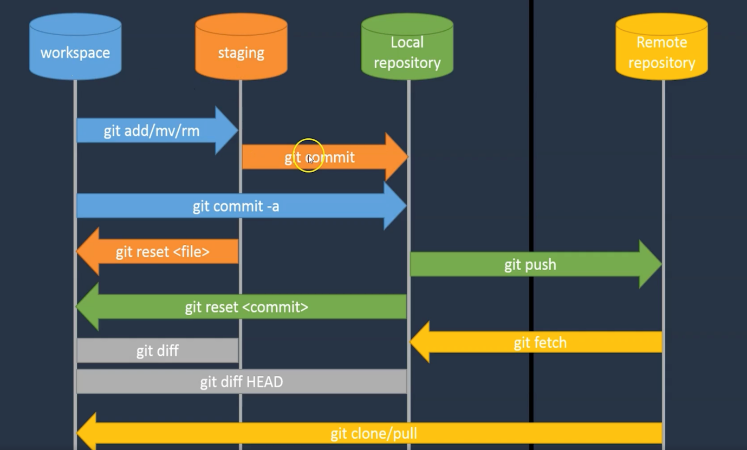

Github Multiuser access

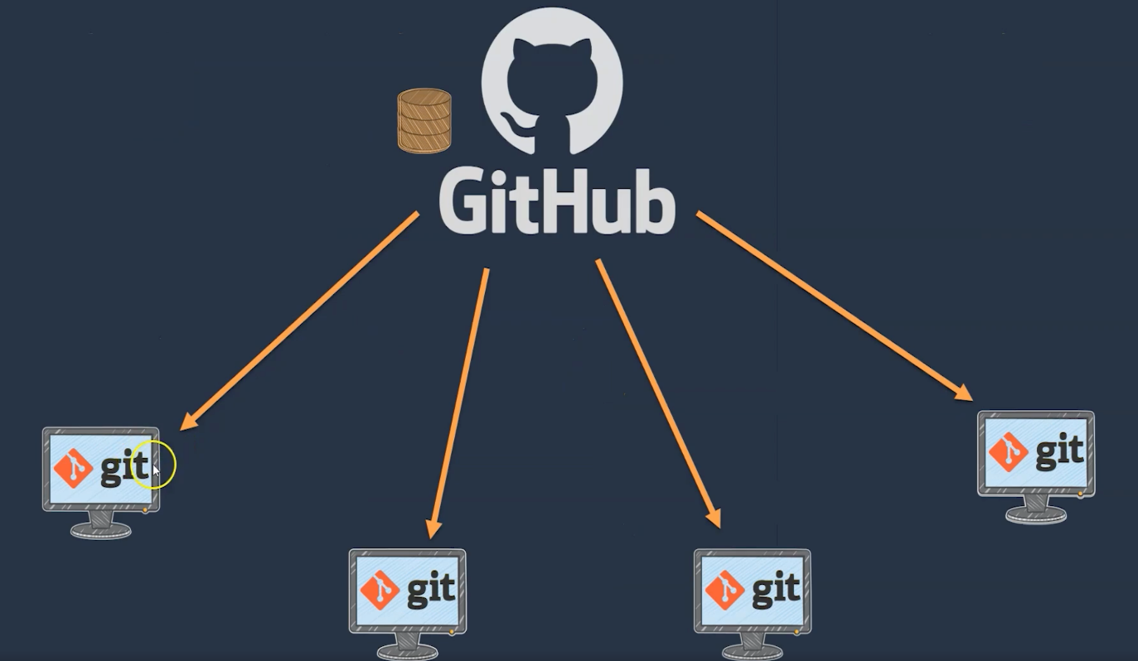

* Git clone

Git clone https://github.com/abhijit2386/GitDemo.git

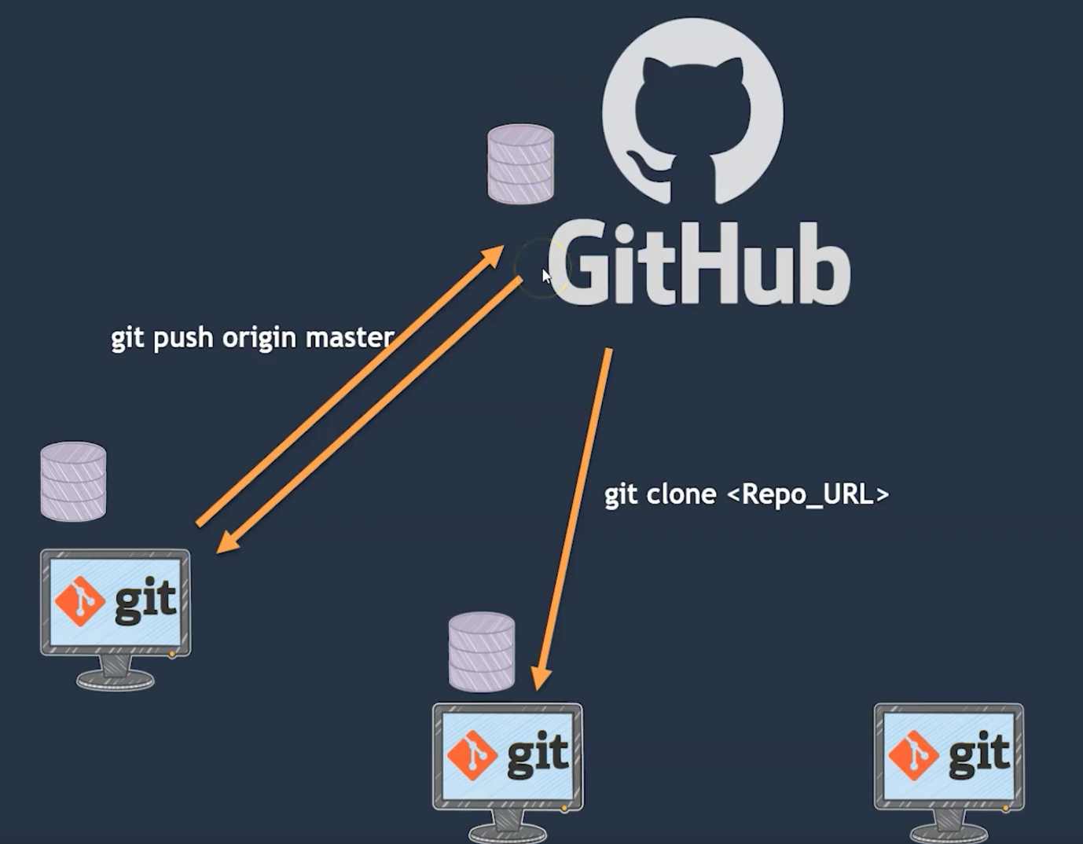

git init

git add README.md

git commit -m "first commit"

git branch -M main

git remote add origin https://github.com/abhijit2386/GitDemo.git

git push -u origin main

* What is difference between git clone and pull

If repository not exist in the system the use git clone cmd.

If repo is exist in local then use git pull cmd.